Superbloom: hear from six of our blooming wonderful volunteers

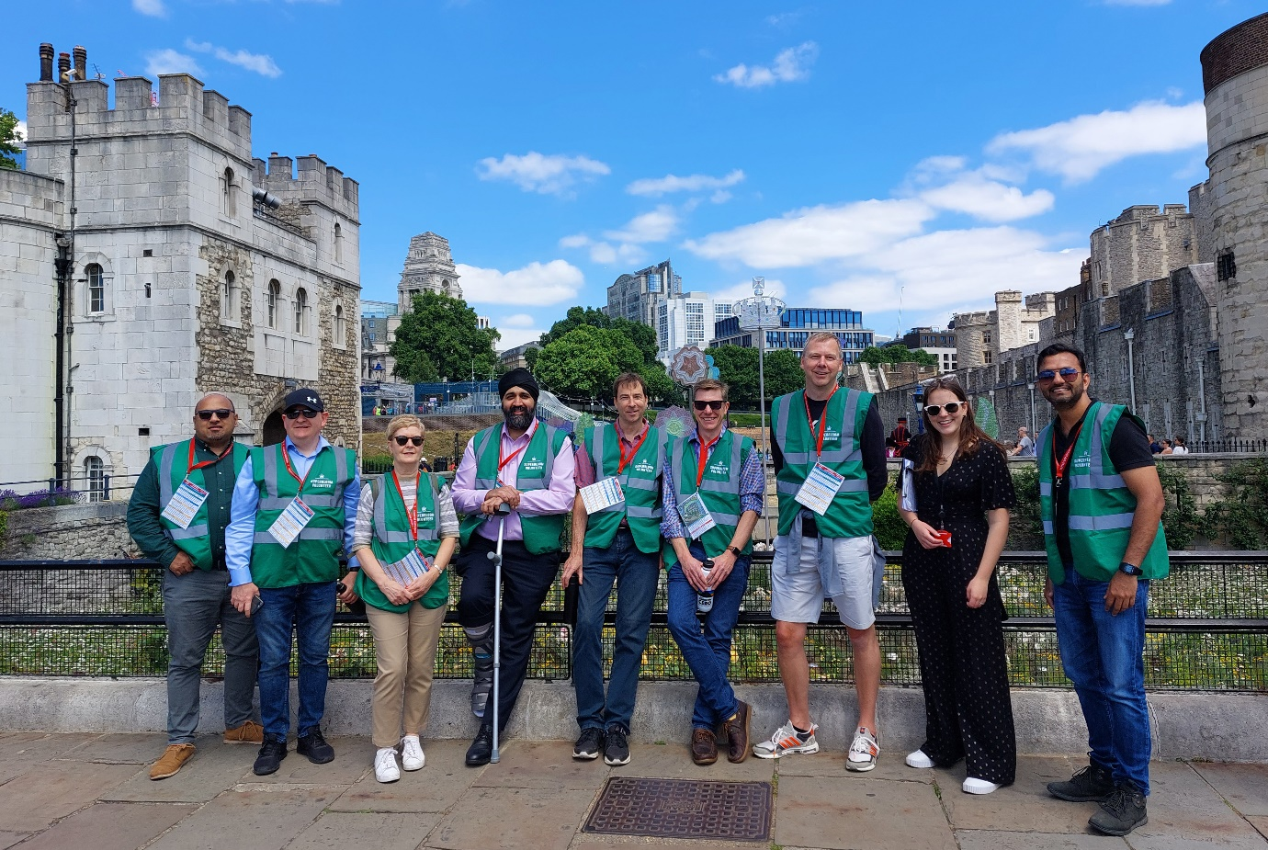
Subtitle: As proud sponsors of Superbloom, 64 of our people have been lucky to volunteer at the stunning spectacle so far this summer.

Over 20 million seeds were sown earlier this year within the Tower of London's moat to create a spectacular, colourful and vibrant sea of flowers to celebrate The Queen's Platinum Jubilee.

Six of our volunteers share the inside scoop about their super experiences at the bloom.

Q: What made you volunteer?
Laura: I saw it as an incredible opportunity to spend the day surrounded by flowers and to help people enjoy themselves.
Karolina: It was a great chance to enjoy nature, especially in this city jungle! I really enjoy getting involved in all the volunteering opportunities that Schroders offers, I believe it’s important to take time to make a difference in the world.
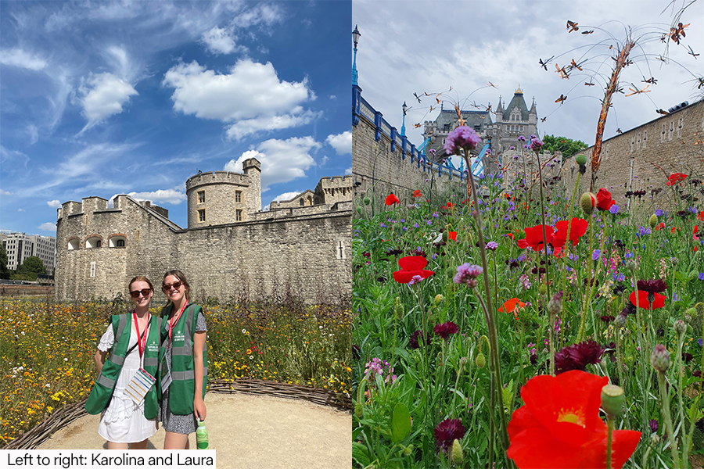
Q: What was involved?
Jing: Directing visitors around the site, helping them make the most of the slide and answering queries about the bloom.
Laura: We also had the opportunity to have an amble, enjoy the flowers and chat to visitors around the display.
Mudassar: Engaging with the public was lots of fun, everyone was relaxed and in a good mood.
Raj: Me and a colleague were lucky to be whisked round The Tower of London in a 10-minute crash course, before helping visitors down the slide, and naturally having a go ourselves!
Q: Your bloom highlight?
Karolina: Spending my afternoon outside, amongst nature with the flowers and the pollinators. It was amazing to see such an array of wildlife in the heart of London.

Laura: I loved the calming music played throughout the moat - designed specifically to complement the white noise of London - which created an amazing feeling of tranquility.

Raj: Talking to and welcoming a wide range of people. I got a very interesting insight into the Yeoman Warders daily lives, popularly known as ‘Beefeaters’. The Yeoman Warders were originally part of the Yeomen of the Guard, the monarch’s personal bodyguard who travelled with him. Today the Yeomen Warders give visitor tours and carry out ceremonial duties, such as unlocking and locking the Tower every day in the Ceremony of the Keys.

Mudassar: The beautiful sight of flowers with the backdrop of the Tower of London. It was a great opportunity to step away from my desk and enjoy an experience close to our office.
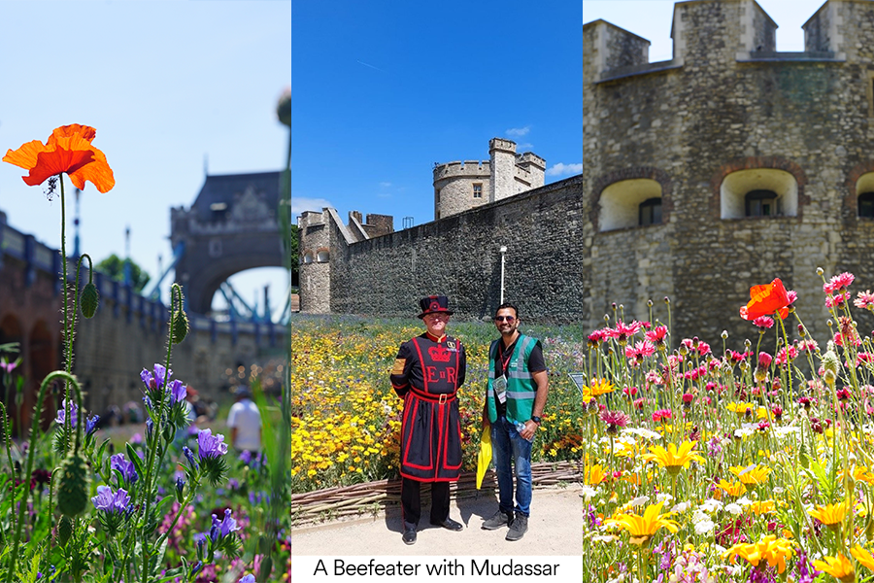

Q: Biggest challenge?
Raj: Trying to help the visitors name the different flowers. There were so many species!
Q: Did anything surprise you?
Robert: Just how splendid and quiet it was.
Jing: By helping visitors with their questions, I learnt a lot about the history of the Tower of London and surrounding area.
Laura: I hadn’t realised that the flowers will now be a permanent part of the moat, it was a nice surprise that they aren’t just staying for Superbloom.
Karolina: How relaxed, happy, and energised I felt afterwards to do more volunteering.
Q: Your favourite bloom?
Robert: A Protea Compacta for its boldness. And thistles because they’re easy to grow and come back each year - and the bees love them!
Jing: Red poppies, they have such vibrant colour.
Laura: A forget-me-not – they’re so delicate and pretty, and it’s always a nice surprise spotting them in the wild!
Karolina: Sunflowers, as they shine happiness.

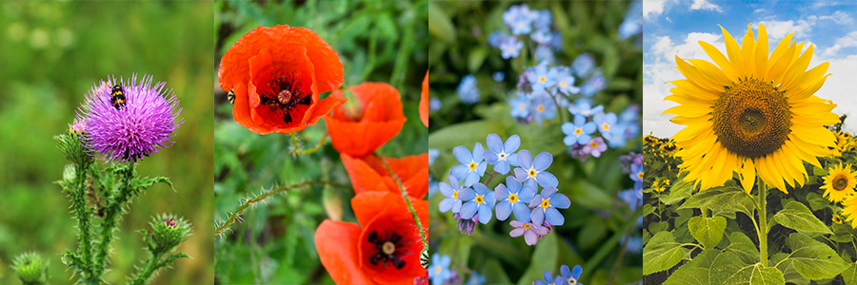

Q: Your key takeaway?
Jing: I felt privileged to be part of the Queen’s Platinum Jubilee celebration and it was a bonus to interact with so many wonderful people and my brilliant colleagues outside of the office.

Robert: Volunteering gives you an opportunity to experience more in life, to meet different people and do things that might otherwise be outside your bubble.
Mudassar: It felt very special to take part in this event at this historic site; a once in a lifetime celebration.

Supporting our people
We support our people in the causes which matter to them, from global employee engagement campaigns on current topics, to running employee charitable matching and volunteer schemes. Find out more about working at Schroders.

